IMPERIAL COLLEGE BUSINESS SCHOOL

Imperial College London

MBA Consultancy Project Report:

Aircraft Oversupply Analysis for Asia Market

By

Shin-Ping Lee (CID: 00417462)

Email: shih-ping.lee16@imperial.ac.uk

A report submitted in partial fulfilment of the

requirements for the MBA degree and the Diploma of Imperial College London

November 2017

# SYNOPSIS

This is a consultancy project report for GE Capital Aviation Services (GECAS) Airline Strategy Team. The purpose of the project is to provide GECAS with an additional market insight, with the result of analyzing the degree of the likelihood of overcapacity in Asia by 2022 with specific focus countries that would benefit GECAS with internal risk assessment for planning their short to medium product strategy to airline clients.

We begin with a description of the client (GECAS) and the rising concern of too many aircraft appears on the order book within the next decade, especially from Asia Airlines comparing to other region. Excess aircraft in the region represent excess supply of seats offer in the market, while supply larger than the underlying demand, yield (value) for Airline will drop. Eventually, the drop in yield would harm the profitability and might cause airline default the lease rate payment to lessor, return the aircraft before the agreed term or sale the asset (Aircraft) on a discounted rate that ultimately impact the residual value of the asset, which is the least thing any leasing company would like seeing happening.

Next, we will be covering a comprehensive discussion of problematic dynamic in aviation industry to cause unpreventable constant oversupply; in addition with the new drivers observed in recent years that would also impact the supply and demand dynamics.

The main part of this analysis will be focus on demand/capacity forecast model and the result will be summarized by country of origin basis. The data we used in the analysis are based on leading industry data provider where GECAS has provide the access for the analysis and will be explained in chapter xx.

Lastly, conclusions with recommendations would be provided as additional information for GECAS’s further discussion of industry overcapacity phenomenon internally and even to externally stakeholders. On top of that, a positive guideline to GECAS’s Airline Strategy Team for their future strategic planning toward to Asia clients.

# ACKNOWLEDGMENTS

First of all I would like to thank my supervisor Professor xxxx for his time and assistance during this project.

I also want to thank the GE Capital Aviation Services Airline Strategy Team for guiding me during the project and giving me all the tools I needed to complete this project successfully.

Special thanks to Cronan Enright, the manager of me when I was working in GECAS from February 2015 till November 2016. During the time under his lead, we have accomplished many different projects together and it was the greatest career experience I have ever had. His influences not only change the way I approach work but also lift up my self-confident willing challenge myself more. He was also the person who wrote the recommendation letter for my MBA application with Imperial College Business School. Last but not least, he even provides the consulting opportunity for my final project with access to the most update-to-date industry data and extra supports. He is not only the mentor but also a life time friend to me indeed.

Furthermore, I also want to thank Imperial College Business School staff and teaching department, the MBA experience was the toughest time of my life but the lessons I learned during this past 21 months not only help me to complete this project but most importantly is to build my knowledges and skills for future challenges.

Finally I would like to thank my family and friends, who have been unconditionally supporting me in every single ways, I appreciate I have you all in my life.

# TABLE OF CONTENTS

SYNOPSIS 2

ACKNOWLEDGMENTS 3

TABLE OF CONTENTS 4

INDEX OF GRAPHICS 6

1. Executive Summary 7

2. Introduction 8

2.1 GE Capital Aviation Services 8

2.2 Origins of the project and client needs 9

2.3 Consultation Project Remit 9

3. Introduction to Overcapacity in Aviation Industry 11

3.1 The Consequence of Overcapacity 12

3.2 Primary causes of overcapacity 14

4. Why Asia 23

4.1 Asia a rising star to GECAS 23

4.2 Record Aircraft Order as a Risk 24

4.3 Asia Air Traffic Demand 26

At the highest level, economic activity is a significant driver of air transport demand. Since 26

Asia has become the engine for global product demand growth, the GDP growth is forecasted to be 3.9% which is exceeding the global average GDP growth of 2.8%, driving by developing countries such as China and India. 26

4.4 Asia Capacity Growth 29

IndiGo’s aggressive growth is pushing others to expand 29

5. Likelihood of oversupply in Asia 32

5.1 Mythologies 32

5.2 Model result 33

4.4.1 China 33

4.4.2 India 33

4.4.3 Indonesia 33

4.4.4 Malaysia 33

4.4.5 Vietnam 33

4.4.6 Philippine and 33

4.4.7 Thailand 33

6. Conclusion and Recommendation 34

7. Appendix 34

8. References 34

# INDEX OF GRAPHICS

# 

## 1. Executive Summary

<https://crucialperspective.com/airlines-demand-supply-analysis-asiapacific/>

<https://seekingalpha.com/article/3959609-excess-aircraft-industry-will-lead-downfall>

* ~~Excess In The Aircraft Industry Will Lead To Its Downfall~~
* ~~Strong emerging markets and high oil prices have led to excess in the aircraft leasing industry~~
* ~~Now with low oil prices and struggling emerging markets, the industry is fraught with oversupply problems~~
* ~~AerCap Holdings and Air Lease Corporation are the two best short candidates to play the coming correction.~~
* ~~Capacity growth and utilization. Although capacity growth is a major revenue driver for airlines, it could be useless if airlines are unable to fill up these newly added seats. Overcapacity in the past has known to cause price wars among airlines, thus reducing their yields.~~

## 2. Introduction

## 2.1 GE Capital Aviation Services

The client, GE Capital Aviation Services (“GECAS”), is an Irish–American commercial aviation financing and leasing company founded in 1993. In the two decades since its creation GECAS has remained the world’s largest lessor by number of aircraft according to Airfinance Journal (Airfinance journal, 2015). Until today, GECAS remains the legacy as the largest commercial airline leasing/financing company in the world by number of aircraft (Figure- XX).



Figure XX: Top global aircraft lessors by managed commercial passenger aircrafts Source: ASCEND as of October 2017

The core business in GECAS is to provide the fleet solutions, such as aircraft leasing and financing, to worldwide airline customers. By supporting a wide range of aircraft portfolio and in-depth industry knowledge with well established reputation, there are 182 airline customers in 66 countries where GECAS provides commercial passenger aircraft solutions (Until October 2017).

The airline strategy team has particular strengths in in-depth market assessment for GECAS and strategic fleet solutions consultation for airline clients and based in multiple locations of Dubai, London and Singapore, in order to provide GECAS’s client nearest support with the most updated region knowledge. Recent work has included xxxxxxxxxxxxxxxxxxx.

### 2.2 Origins of the project and client needs

This consultancy project was initiated by GECAS Airline Strategy Team therefore the focus of assessment and recommendations would be focus on strategy side rather than finance side but considers the company as a whole. The project came from a request by GECAS for a study into the likelihood of overcapacity in Asia region in the next 5 years where GECAS has observed a record orders of aircraft will be deployed into the region, with an abnormal order behavior between few particular airline clients in the region.

As a rule of thumb of economic theory an excess in supply will cause a reduction in the equilibrium price. Applying the rule to airline industry means airlines will need to drop the ticket price otherwise the seat will go empty when airlines ordering too many aircraft than they need. The consequences GECAS concerns is that when airlines fail to earn the cost of capital due to shirking profit margin, the likelihood of delay or default of lease payment, or lack of sufficient time to release the aircraft to next client due to early return of the asset from unprofitable airlines, would eventually harm GECAS’s operation and finance performance.

Therefore, to have an insight of the market and the likelihood of overcapacity in the region of the next 5 years would be beneficial for GECAS internal risk assessment where GECAS can redefine or early adjustment their portfolio deployed into the region, country or even to a particular airline client.

### 2.3 Consultation Project Remit

In this report we attempt to cover the considerations and appropriate measures for assessing the supply-demand balance across the industry, with a focus on leasing companies, OEMs and Airlines, as well as the consideration of time and geographic markets, where the client (GECAS) interrupted the most. It is hoped that by providing an inclusive perspective and key system metric, industry trend observations and analysis to client for additional information for their future strategic planning.

#### 2.3.1 Aims of the study

The aims of the project are to:

* Review the primary cause of overcapacity in the aviation industry.
* Discuss the recent trend industry observed that may cause further overcapacity.
* Forecast the likelihood of overcapacity in the region by modelling the retirement age split by lease and own aircraft from airlines.
* Conclude the result and suggest the country to focus by the degree of oversupply.

#### 2.3.2 Specific Deliverables

A list of specific deliverables was agreed with the client, due on dates between Feb and March 2018.

* A summarize table with degree of overcapacity from 2017 to 2022 by focus countries.
* A brief explanation and conclusion on each focus countries.
* Quantitative details, methodology and modelling assumptions explanation.
* 15 minute result presentation.

A separate, 10-page power point and aircraft projection model will be delievered to the client. The presentation and list of the xxxxxxx are in Appendices A and Bxxxxxx.

## 3. Introduction to Overcapacity in Aviation Industry

Overcapacity, or the balance relationship between the supply and demand of capacity, has been an everlasting debate exists in the aviation industry, by different stakeholders. (Mack, et al., 2013)

The global commercial aviation is composed and influenced by multiple stakeholders such as airlines, governments, original equipment manufacturers (OEMs), airports, and aircraft leasing companies and many more.

It is difficult to define a common “product of supply” among all stakeholders where OEMs consider product as aircraft production and volume but Airport sees airspaces and runway capacity as their product. For the simplicity also the consistency of the scope in this study where airlines, leasing companies and the manufactures are the 3 key stakeholders GECAS interacted the most, hence “product of supply” in this study is defined as number of “aircrafts” or “seats” that widely accepted and commonly in use for measurement between 3 key stakeholders. Furthermore, below figure also demonstrate that Airlines hold a key position in the supply and demand flow of the 3 key stakeholders, which is the primary reason why airlines are the prime focus in this oversupply study.



Figure xx: Capacity Supply and Demand Flow by Key Aviation Holders

### 3.1 The Consequence of Overcapacity

In economic theory, oversupply (equivalent to overcapacity in airline industry), is the situation that the quantity willing supplied by the producers is higher than the quantity demanded by the consumers. Oversupply will ultimately lead to a reduction in price.

(Insert a figure where capacity and average price or yield negative correlated)

Figure xx: Relationship between yield/average fare vs Capacity

In order to keep the supply and demand within equilibrium level, a change in capacity would be required to react when there is a significant imbalance between supply and demand theoretically. However in aviation industry, planning capacity is much more complex where involves multiple levels of uncertainties, such as forward looking based on the imperfect historical data, industry rule of thumb assumptions, but also the fact of external influence and airlines decision maker’s conflict of interest. (Adopted from Mack, et al., 2013).

The most obvious consequences outcome is we can often see when there are excess seats offer in the market, airlines must drop fares to boost the demand up otherwise the seats would go empty. Under an oligopoly environment of strong competition of airline industry that price war is extremely likely to happen when one sees another start dropping the fare. In a long-term accumulation of vicious competition, yield[1] is expected to see constant decrease, which result revenue decline and profit margins shrinks. The worst scenario, bankruptcy, we can name the most recently case of Monarch Airlines in the U.K as an example.

The potential causes of overcapacity in the industry is summarized and discuss in the following chapter.

Figure XX:

~~The shirking trend of profit margin observed from Airlines alert all stakeholders as Airline is the center of the aviation revenue chain (see figure xx). GECAS, as one of the leading leasing companies will need to plan ahead, understand the likelihood of overcapacity in the Asia market, for their risk department to have additional information to forecase, or set a cap, of the exposure to vonluntered airlines, to avoid the potential of default in lease payment, or need to release the asset due to airline bankruptcy.~~

### 3.2 Primary causes of overcapacity

(Insert a figure of issue tree)

#### 3.2.1 Fundamental Industry Problematic Dynamic

The industry's disequilibrium, is driven by, a fundamental problematic dynamic that intrinsic and unstoppable tendency to provide too much capacity (Doganis, 2010) . The nature of the business, the accumulated historical data bias, the revenue chain and government influences are all responsible for the irreversible outcome.

##### 3.2.1.1 The myth of historical growth

Historical growth of air traffic demand, or the percentage change in air traffic demand within a specific time period, often use as a baseline when forecasting the future demand. However there is a blind spot that often being ignored, or underestimated that historical rate is actually the sum of two very different type of demand growth: **underlying growth** which driven by external factors and **induced growth** is driven by mainly airline’s business decision itself. (Love, 2006).



Figure xx: Historical Demand Growth Components

Hence, by applying the historical rate as a blanket growth when estimating demand is already includes a certain degree of over-forecasting if airlines is unable to distinguish the underlying and induced demand. Overtime, the compound factors is almost sure that over-forecasting for the future which simultaneously increase the probability of excess capacity planning to the future. To avoid seats would go empty, airlines has to lower price in order to induce demand which gradually putting the yield to a lower and irreversible level.

##### 3.2.1.2 Cyclical Behaviour of Aviation Industry

1. **Economic Cycles and Aviation Cycles**

Strong cyclical phenomena have been noticed in airline industry. Generally, the traffic growth comes after economic growth and airlines start ordering aircraft after a good year of operating result to get ready for future expansions. OEMs normally deliver aircraft after 2-3 years after receiving the order. As economic temp to be cyclical that airlines order the aircraft in a good year but can only be delivered after good years have finished, the capacity adjustment lead time have again cause a cyclical excess in capacity in the market.

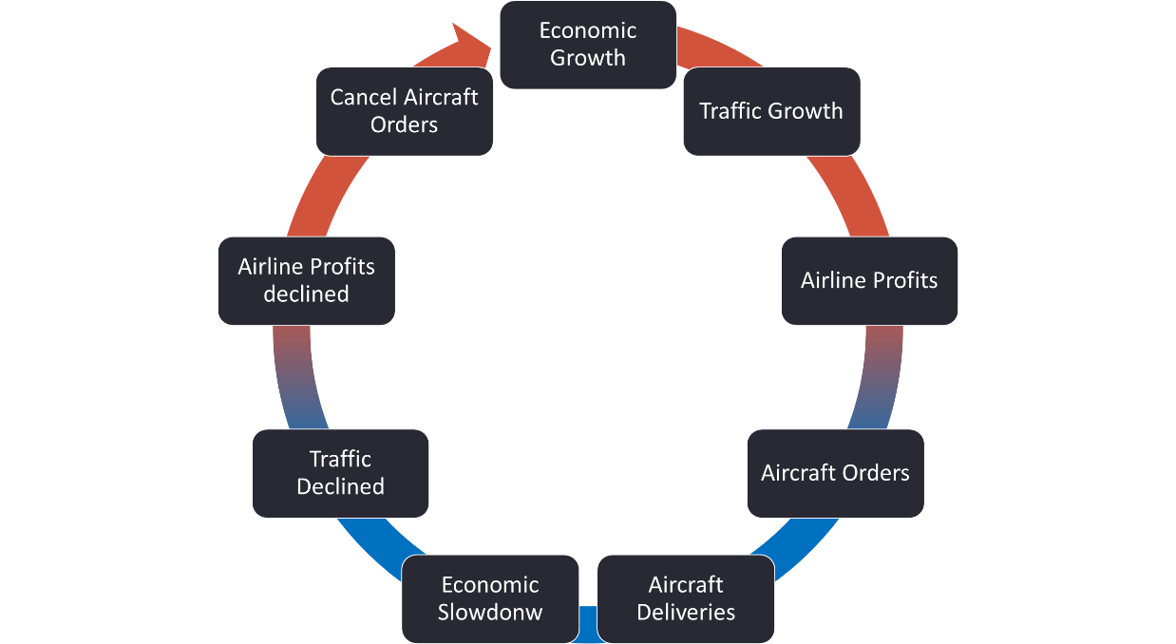

Figure xx: Aviation Cycles

1. Capacity adjustment and lead time

Theoretically speaking, disequilibrium between supply and demand can be fixed, or adjusted, by changing in capacity of supply. Besides the challenge of forecasting the level of capacity adjustment that mentioned in chapter 3.1, the various lead times inevitably result in lags actually is the prime reason that drives capacity problems. The longer the lag period, the greater the opportunity for a change in the circumstances of the current competing environment and assumptions airlines made initially.

*“Typically, adjustments introduce a further lag. Correcting the new plan may require additional adjustment, because there is a tendency to over-correct and the adjustment lag allows circumstances to change in the interim.”*

*Capacity adjustment lead time*

1. Survival the unfittest

A free market economy is drive by individual innovation and profit orientation, the concept of competition is an important component of a free market system that an unfit firm who couldn’t compete successfully will be illuminated in the market place naturally.

However in the case of airlines where there is a long history of subsidized “flag carrier” across the world, government involvement direct or indirectly result an unfair competition in an oligopoly environment. Because of the “state-owned carriers don’t die” phenomenon that drivers those carries lack of motivation and innovation, override shareholders value, insensible of profit maximisation, at major driver of managers decisions.

The industry profit margin will be continuing suffering, if there are too many unfit carriers with political intension with irrational business decisions, artificially pour in excess capacities beyond the demand to a market what it has been seen historically.

1. Airline is The Center of Aviation Revenue Chain

The revenue model between key aviation stakeholders is demonstrate in figure xx. Apart from airlines generates revenue from passengers when providing air services, other stakeholders all generate revenue from Airlines. Therefore Aircraft and engine manufactures likely to persuade airline ordering more aircraft for recurring revenue, leasing companies encourage to lease more for lease charges, bank support airlines to borrow loan for more interests payment and airport promote airline with incentives adding more frequencies for landing and parking charges.

As a result from the dynamic discussed above, airlines are constantly influenced by other stakeholders with a positive market forecast illusion possible based on a bias assumptions as the result is favorable to other stakeholders themselves.

The figure xx of return on capital within in the value chain explain the phenomena that airlines hold a weakest position on ROIC with stronger business partners around. Apart from airlines and manufacturers, other stakeholders most earn more than or close to their WACC.

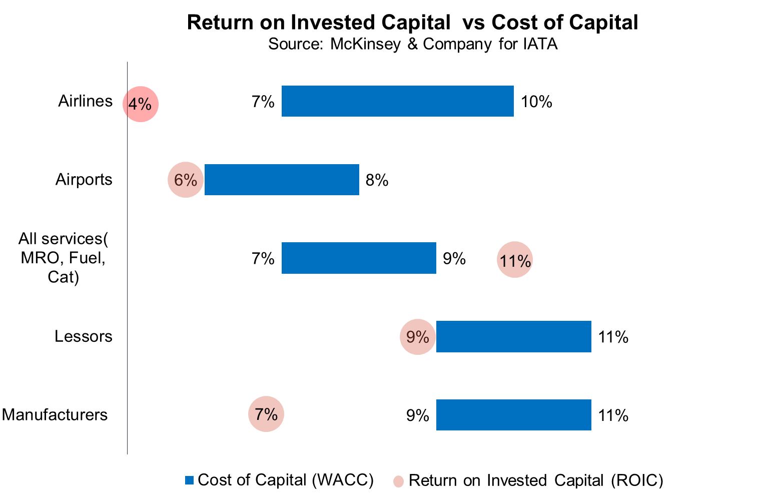



Figure XX: Key Aviation Stakeholders Revenue Models

*MRO = Mantainese Repair and Overhaul

Source: R&P Research (R&P Research, 2016)

#### 3.2.2 Recent Trend Observed to Caused Further Overcapacity

##### 3.2.1.1 Ease of airline to acquired new aircraft

Aircraft, well know as global and mobile asset with a stable cash flow backed by long term contracts, in addition, the predictable long term returns with low volatility compared to listed equities. Hence, it is always being a popular option for investor for a geographically diversified investment. (Capital Aviation , 2017)

Traditionally, if airlines need to purchase aircraft there are several sources for aircraft financing such as cash, capital market, bank debt and export credit agent.

As the growing middle class and global air passenger traffic showing a long-term growth trend, indicates that demand for aircrafts appears to be strong in the future. In the recent years, many non-traditional investors have been seen entering the market gradually which also indicate that the new platform as listed below for capital is available in the market:

* Sovereign Wealth Funds (SWF)

As PWC Aviation report state that they have seen a number of SWF-backed

* Export Credit Agency
* Financial Investors/Private Equity
* Far Eastern Banks

(Shift in aviation assets from European banks to the banks in asia is likely to continue) Chinese banks entre the foray after deregulation post 2007

Many financial institutions, led by China’s big banks such as ICBC, CCB, CDB, Minsheng, CMB and Bank of Communications, started building up their aircraft-leasing arms and developig their own capabilities and scale in this segment.

##### 3.2.1.2 The need of new technology aircraft

* + Fuel save, long range, customized interiors
  + A continued focus by airlines on driving down operational cost with new technology aircraft with innovative improved composites and more fuel efficient engines
  + New technology aircraft with lower carbon emissions also help airlines with broader environmental objectives and better place them for a future when global carbon pricing is fully implemented

3.2.1.3 Rising production rate of OEMs

3.2.1.4 Lessors make it easy

* + Xx% aircraft are leased from operating lessor in 2017 comparing to xx% in 20xx. Even for airlines with weak balance sheets or start-up and LCC with only project balance sheet, to acquire additional capacity.

1. New entrants growing of aircraft lessors in Asia

Top Chinese Lessors graphs

##### 3.2.1.3 Airline Itself

1. The market share game obsession

The tendency towards overcapacity is reinforced by airline executive’s obsession at maintaining or enhancing market share on key routes at almost any price. Adding more obsession of legacy carriers with market share has pushed them into costly head-on battles with low-cost airlines that they rarely win.

* Game Theory

As the oligopoly nature with limited of players in the industry

IndiGo’s aggressive growth is pushing others to expand

Unprecedented capacity expansion by Indian carriers to match the aggressive growth agenda of IndiGo would push airlines towards reduced profits and larger losses in FY2018 due to pressure on yields on account of offer of low fares, Centre for Asia Pacific Aviation (CAPA), the aviation think tank has said.

“IndiGo’s increasingly aggressive and unprecedented growth is creating a strategic compulsion for others to expand to remain relevant in the market. This is driving over-capacity and increasing industry risks for most carriers,” CAPA said in its outlook for 2018.

IndiGo has the largest fleet of 135 aircraft, and the largest order book of any airline in the world at 458 aircraft. Its fleet could expand by 46 aircraft during this financial year.

Besides, the airline has announced an order for 50 ATR-72s and possibility order A330neos for long haul services.

“Other carriers are responding by accelerating their own expansion to hold on to market share and to prevent IndiGo from securing a dominant position with over 50% of the market,”Kapil Kaul, CEO, South Asia, CAPA said.

This expansion will place immense pressure on the aviation system.

Of the expected 1080 aircraft on order, more than 700 are scheduled for delivery within the next decade and 400 within the next five years. This excludes orders yet to be placed and equipment to be taken on lease.

1. Replication of successful LCC
2. Conflict of interests of airline leaders to drive irrational business decisions
   * Irrational competitions
   * The need to under spotlight,
3. Airline become lessor itself

## 4. Why Asia

### 4.1 Asia a rising star to GECAS

As to October 2017, Asia has the 3rd largest percentage share globally by aircraft in service that GECAS is managing, with the highest CAGR growth of 11.7% between 2002-2017 among the GECAS top 3 regions and expected to grow at a rapid rate industrywide driven by growth of the middle class in emerging markets and increasing low cost carriers in Asia.



Figure XX: GECAS fleet shares by Regions

Source: ASCEND as of October 2017

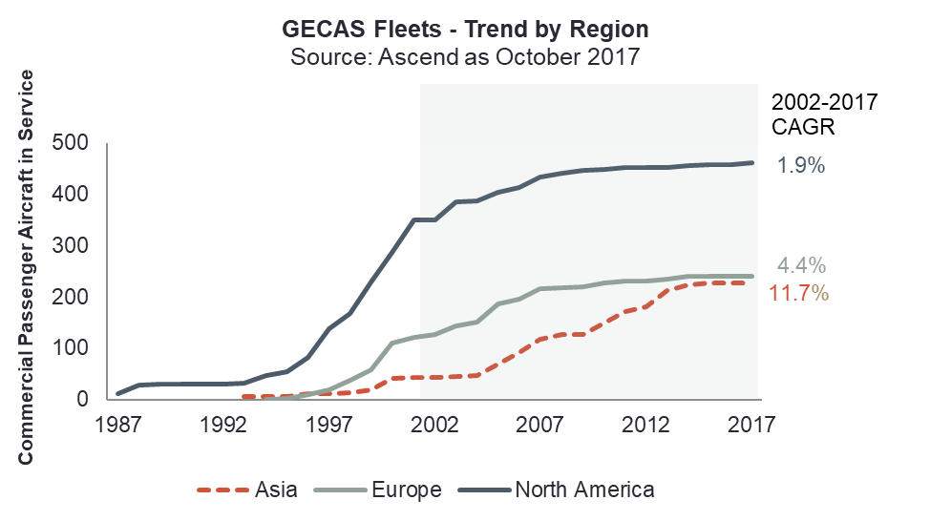

Figure XX: GECAS Fleets – Trend (1987-2017) by Top 3 Market Regions

As the importance of Asia region, GECAS has requested a region focus study in this report, particularly in 5 emerging countries of China, India, Indonesia, Philippines and Thailand, where GECAS has the most customers and aircraft deployed.



Figure XX: XXXX

Source: ASCEND as of October 2017

### 

### 4.2 Record Aircraft Order as a Risk

By looking at the global aircraft orderbook that Asia has the highest percentage among all regions, with 37% share equivalent to 3,464 aircraft on order, almost similar share to Europe and North America combine. The reason was primarily driven by 3 airlines operates in Asia, Lion Air, Indigo an AirAsia, where the order aircraft schedule to be delivered almost 400 for each one of them, in a very soon future year, in a close by geographic location.

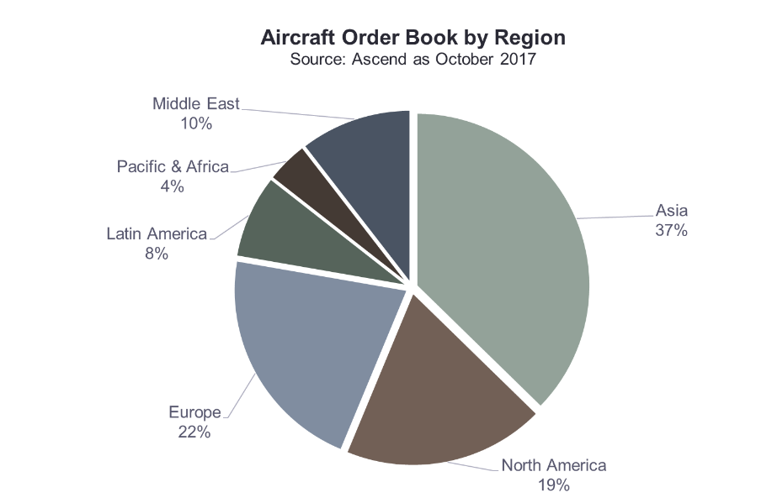

Figure XX: XXXX

Nevertheless, a high order backlog number doesn’t not necessary alert the concern as we shouldn’t look at the orders in an isolation way, the current fleet in service is also required to take into consideration as it represents the size of operation and the complexity of the network that each Airlines is operating. As figure, Asia Airlines not only have the high order backlog but also with an extremely high order to current fleet ratio, which means the order aircrafts is way above their current operation needs indicates that either Airlines would need to expend their operation rapidly and simultaneously keep sufficient profit margin, to keep the asset in good use and healthy finance position for lease or interests rate payment to finance the assets.



Figure XX: Airlines with Most Order Backlog – Ranked by Passenger Commercial Aircraft on Order

Source:

2) Backlog to in-service fleet ratio is defined as “Current order backlog / In-service fleet”

### 4.3 Asia at a Glance

#### 4.3.1 Air Traffic Demand

At the highest level, economic activity is a significant driver of air transport demand. Since Asia has become the engine for global product demand growth, the GDP growth is forecasted to be 3.9% which is exceeding the global average GDP growth of 2.8%, driving by developing countries such as China and India.

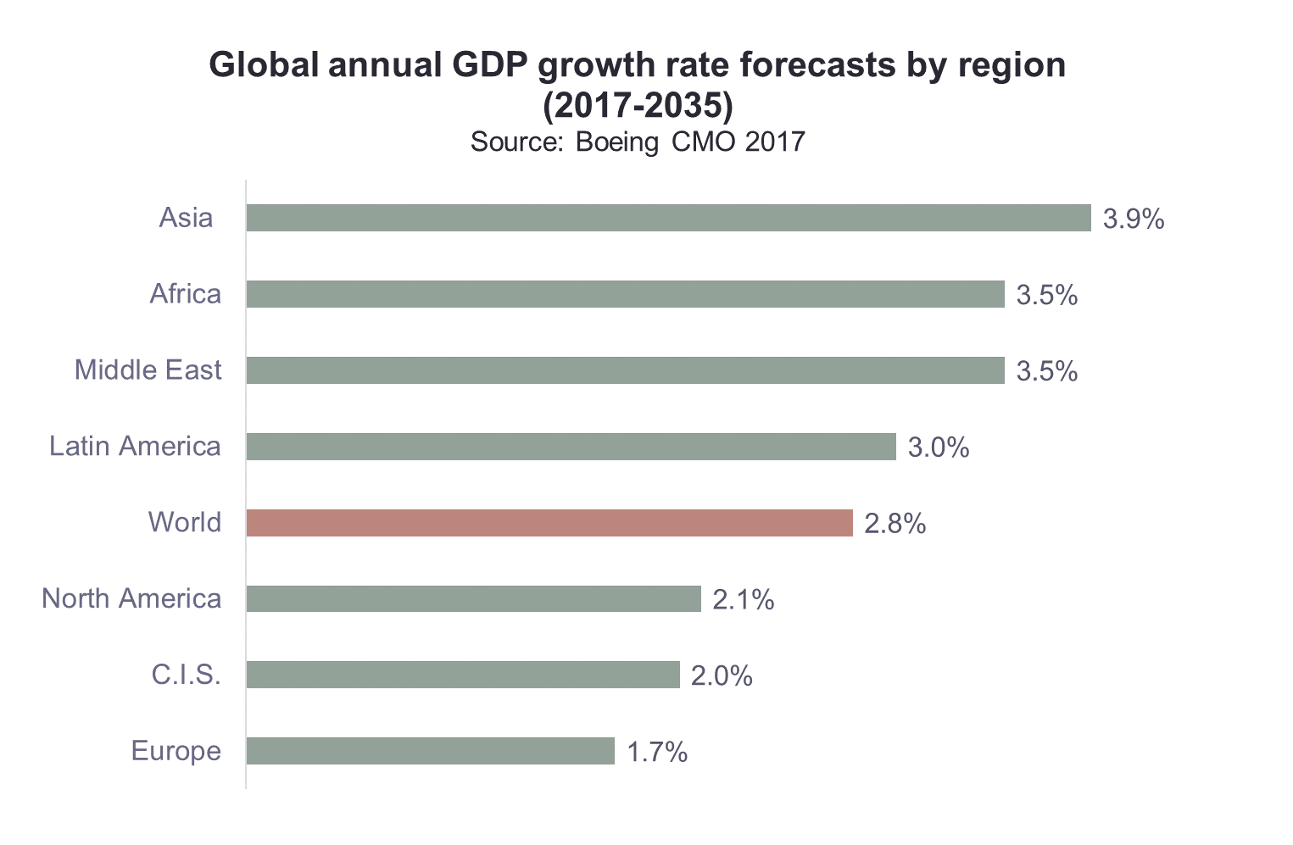

***Figure:XXXXXX***

*Source: XXX*

Secondly, a favourable demographic trend, such as population growth, growing middle class population and higher consumer spending would also boost the air traffic demand. According to Airbus GLOBAL MARKET FORECAST (GMF) 2017-2036 report, the wold middle class population is forecasted to grow from 38% to 55% between 2016 to 2036 as a percentage share to total population as figure xx.

In Asia-Pacific that middle class population almost double over the next 20 years, with a second highest annual average growth of 3.6% followed by Africa, way beyond Europe and North America region. Indicates a very active travel demand intra-regional and international. (See figure xx).

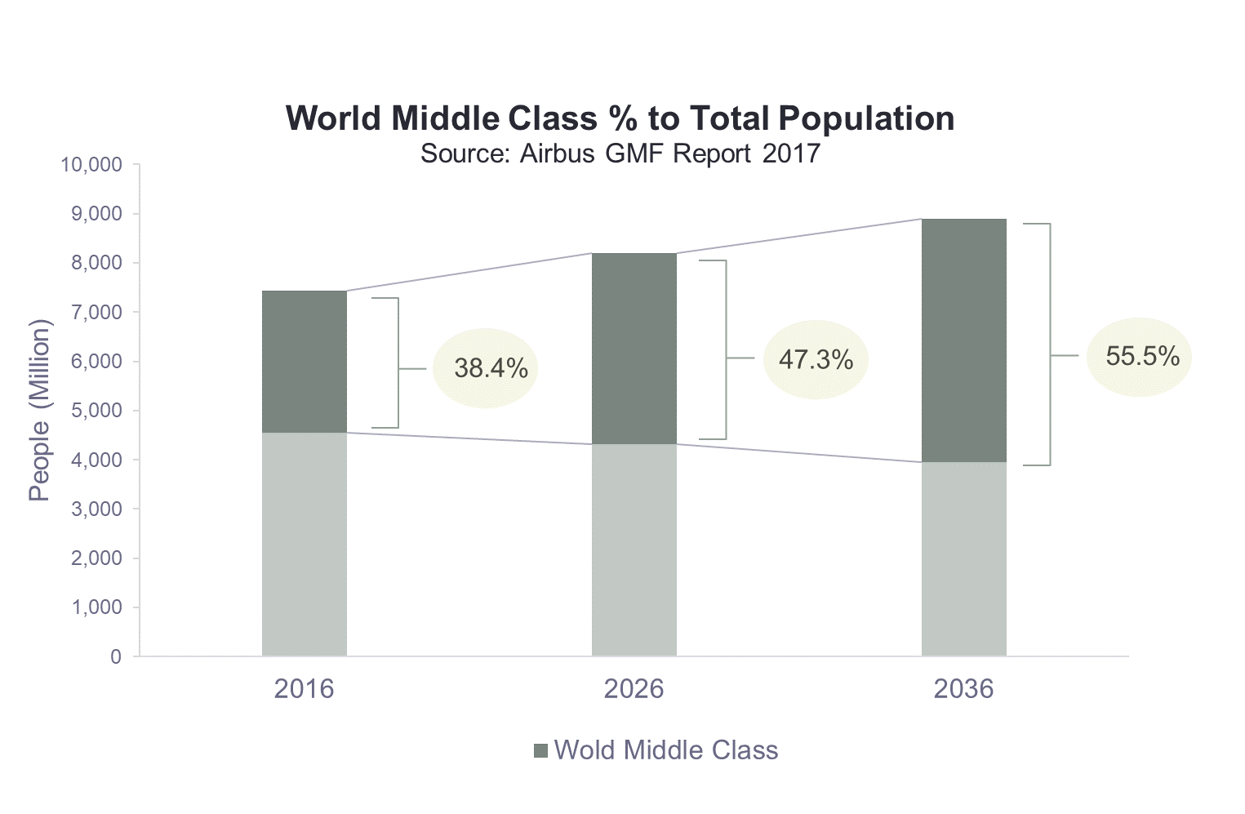

***Figure: 20 Years Middle Class Populations % share to total populations (people in million)***

*Source: Oxford Economics, Airbus*



***Figure xx: 20 Years middle class households (people in million) – Split by Regions Note: Households with annual income between $20,000 and $150,000 (PPP constant 2016 prices)*** *Source: Oxford Economics, Airbus*

As the result of steady economic growth with rising middle-class population and globalization, (with greater connectivity …..) that Airbus forecast that the expect the propensity to travel is likely to remain a uptrend in the next 20 years.

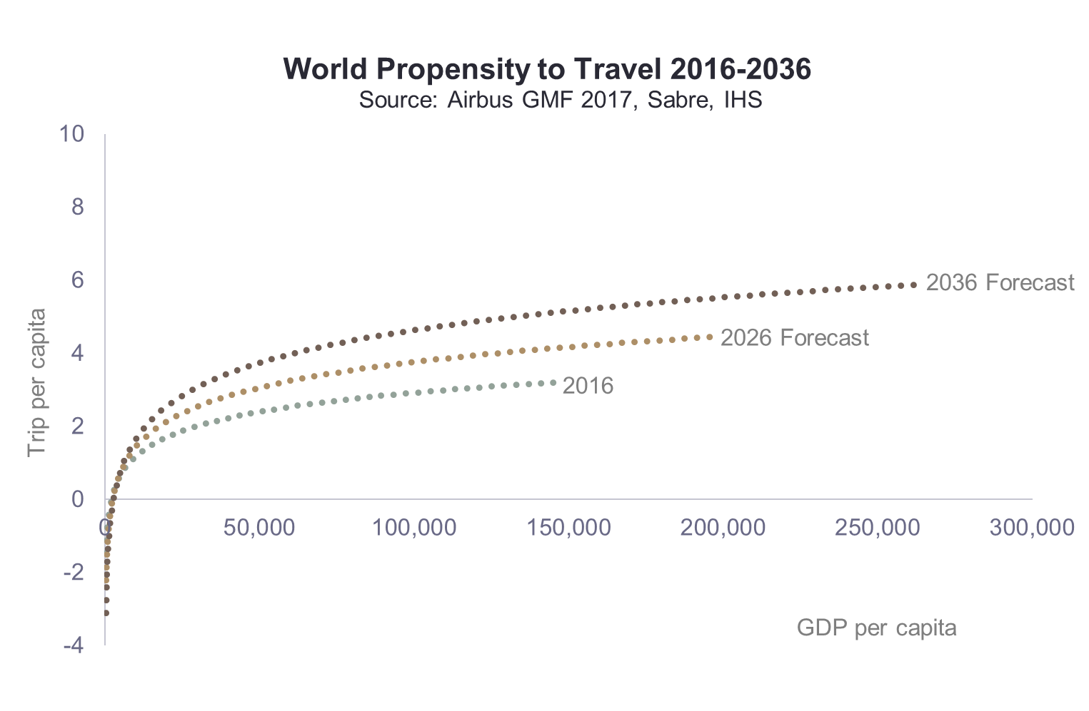

Asia is forecasted to have the second highest propensity to travel growth rate in all regions. Within selected emerging countries in Asia, India has the lowest trips per capita only 0.1 in 2016 and 0.4 in 2036. However in the absolute terms, given its population of 1.32 billion with the forecast of 4 times increase in the next 20 years, indeed the air traffic in India holds a strong potential, similarly to China.



***Figure xx: Average Trip per Capita***

*Source: Oxford Economics, Airbus*

#### 4.3.2 Asia Capacity Growth

##### 4.3.2.1 Country of Focus

#### 4.3.3 Asia Fleet Growth

4.3.3.1 Country of Focus

#### 4.3.4 Asia LCC Growth

4.3.4.1 Country of Focus

## 

Airline industry has a cyclical industry nature, strong correlation to economic activities, sensitive to fuel price and interests rate fluctuation, fragile to political shocks and disaster. Besides that, airlines also with high cost of capital to entre and high sunk cost to exit. In addition to that, Airlines also facing fierce competitions especially the growing popularity of low cost carriers combine the relax of traffic right between countries.

To strive for survival, airlines force to seek ways to expand their network by increase their capacity seats to current or new destinations that trying to remain market share. However, airline can still earn a considerable profit when the economic activities is strong that capacity growth as the same speed of demand growth, problems only begin at the moment where airlines adding too many capacities at the same time and at the same markets, but at the wrong timing, where the capacity growth outpace the demand growth.

## 5. Likelihood of oversupply in Asia

### 5.1 Mythologies

Complex sytems require the use of several indicators in order to make the most informed assessments of status. Further, the combination of multiple indicators provides the holistic perspective sought and is generally considered as best practice. It is possible occasionally that key indicators alone may not provide sufficient clarity on status. For example, if indicators display conflicting assessment results, it may help to review some ancillary indicators to provide additional clarify for the overall assessment.

The most widely relevant indicator are as below:

System available seats, measured in ASK, are probably the most essential measure of capacity, representing the network seats airline supply to the system to meet expected demand. The ASK capacity metric requires conversion into to the growth of ASK per unit time ( Typically year-over-year annually or quarterly) and may be compared to the nominal range from historical ASK growth observed over multiple historic time periods. In this form, ASK data prove the most useful indicator.

Crucially, a rise in ASK is typically associated with a nearly simultaneous rise in revenue passenger kilometer (RPK) demand (sometimes a slight lag or lead may occur). Thus any significant variation of ASK growth outside of the nominal range is only a relevant indicator of a potential imbalance if it significantly decouples from the RPK demand growth.

Associated with ASK capacity and RPK demand is the passenger Load Factor(PLF) which determines the portion of filled or demanded capacity. This component of key indicators is usable in its raw form as a percentage value. Again the data for PLF are compared to a nominal range. Because PLF has developed along a growing trend over time, the nominal range must be defined around that trend.

Aircraft utilization which is an indicator necessary to understand how hard the fleet is being worked. Comparison to the nominal range established by historical values and industry levels can also provide insight into likelihood that the system can flex utilization to balance capacity. In addition, overall Commercial Aircraft Fleet net growth indicators include over time:

* The number of expected new aircraft deliveries.
* The number of viable modern technology aircraft (Typically, in –production types).

That are not being utilized, that is, the parked fleet and

* The number of expected retirements of obsolete aircraft to be removed from use.

A metrix of the aforementioned measures will provide the most important indicators of capacity status and, together, will provide data for near-term capacity availability and growth.

AIRPLANE DEMAND The airplane demand forecast phase is the final step of the process. With detailed knowledge of the industry’s current fleet and short-term fleet plans, inclusive of seating configurations, aircraft utilization, fleet retirement schedules, and a backlog of sold aircraft, a base is established to assign current production or future aircraft products to an airline’s long-term fleet. Many things are considered during this phase, including an 56 | Methodology airline’s strategy and brand as well as its current and future route network, and matching those with the appropriate aircraft product that maximizes profitability and capability. The capacity of the incoming and existing fleets must equal the total capacity targets for each participating regional flow and time period.

### 5.2 Model result

### 4.4.1 China

### 4.4.2 India

### 4.4.3 Indonesia

### 4.4.4 Malaysia

### 4.4.5 Vietnam

### 4.4.6 Philippine and

### 4.4.7 Thailand

https://www.mckinsey.com/industries/oil-and-gas/our-insights/profitability-in-a-world-of-overcapacity

## 6. Conclusion and Recommendation

## 7. Appendix

## 8. References

Definition of asia, list

1. Passenger yield is the average fare per passenger, per km. It’s calculated by dividing passenger revenue by RPK (revenue passenger kms)).